Introduction to Sociology for Health Professionals (SOC 1576)

TuTh 11:00am-12:15pm in Gladfelter 748

Instructor
Lauren D. Olsen, PhD
Email: tul69621@temple.edu
Office: Gladfelter 722
Office Hours: 9-10am TuTh

Course Description

This course offers an introduction to the discipline of sociology. Focused on a systematic study of social life, the discipline of sociology offers distinctive concepts and methods to understand human beings and the societies they inhabit. The primary operating principle of sociology is to shift analytic emphasis--common to the health professions--from individual characteristics to the characteristics of broader social contexts, groups, and institutions. This Introduction to Sociology is specifically intended for those with interests in the health professions. We apply each topic we study to issues in health and medicine, pairing general sociology readings with readings specifically on health and medicine. Students preparing for the revised MCAT (2015) are especially encouraged to take this course. Duplicate credit warning: Students who have received credit for SOC 1176 or SOC 1976 Introduction to Sociology (or its equivalent in transfer) may not receive additional credits for this course.

Prerequisites
None.

Course Schedule

Week | Topics/Readings | Assignments + Exams Due
1 | Introduction to the Discipline  - Syllabus  - Taylor, Ann, Caragh Brosnan, and Gwendalyn Webb. 2021. “Equity in the Classroom and the Clinic: Understanding the Role of Sociology in Health Professions Education.” Teaching Sociology  - Aldon Morris’ 2021 American Sociological Association Presidential Address (video: Aldon Morris Speech)
2 | Foundational Theories  - Textbook, Chapter 1. “An Introduction to Sociology”  - Textbook, Chapter 4, “Society and Social Interaction”  - Conrad, Peter. 1986. “The Myth of Cutthroats Among Premedical Students: On the Role of Stereotypes in Justifying Failure and Success.” Journal of Health and Social Behavior 27:150-60.
3 | Identity and Socialization  - Vinson, Alexandra H. 2019. “Short White Coats: Knowledge, Identity, and Status Negotiations of First-Year Medical Students.” Symbolic Interaction 42(2):395-411.  - Textbook, Chapter 5: “Socialization”
4 | Identity and Socialization  - Healey, Jenna. 2023. “‘A Vile Custom’: The Strange Career of William Osler’s ‘Professional Notes’” Journal of the History of Medcine and Allied Sciences 1-21.  - Hafferty, Frederic W. 1988. “Cadaver Stories and the Emotional Socialization of Medical Students.” Journal of Health and Social Behavior 29:344-356.
5 | Catch Up and Review | Exam #1 (9/24)
6 | Groups and Networks  - Textbook, Chapter 6: “Groups and Organizations”  - Bearman, Peter S., James Moody, and Katherine Stovel. 2004. “Chains of Affection: The Structure of Adolescent Romantic and Sexual Networks.” American Journal of Sociology 110(1):44-91.
7 | Organizations and Bureaucracy  - Reich, Adam. 2012. "Disciplined Doctors: The Electronic Medical Record and Physicians' Changing Relationship to Medical Knowledge." Social Science & Medicine 74(7):1021-28.  - DePalma, Lindsay J. 2021. “The Passion Paradigm: Professional Adherence to and Consequences of the Ideology of ‘Do What You Love’” Sociological Forum 36(1):134-58.
8 | Culture and Institutions  - Textbook, Chapter 3: “Culture”  - Sointu, Eeva. 2019. “Challenges and a Super Power: How Medical Students Understand and Would Improve Health in Neoliberal Times.” Critical Sociology 1-15.
9 | Catch Up and Review | Exam #2 (10/22)
10 | Inequalities by Class  - Rank, Mark R. 2011. “Rethinking American Poverty.” Contexts 10(2):16-21  - Jenkins, Tania M. and Shalini Reddy. 2016. “Revisiting the Rationing of Medical Degrees in the United States.” Contexts 15(4):36-41.  - Horowitch, Rose. 2024. “The Perverse Consequences of Tuition-Free Medical School.” The Atlantic 1-9. | Assignment In-Class Brainstorm and Citation Exercise Activity and Submission (10/25)
11 | Inequalities by Race  - Amutah, Christina et al. 2021. “Misrepresenting Race—The Role of Medical Schools in Propagating Physician Bias.” New England Journal of Medicine  - Vyas, Darshali et al. 2020. “Hidden in Plain Sight – Reconsidering the Use of Race Correction in Clinical Algorithms.” New England Journal of Medicine  - Olsen, Lauren. 2024. Curricular Injustice: How U.S. Medical Schools Reproduce Inequalities. Chapter 4.
12 | Inequalities by Gender and Sexuality  - Martin, Emily. 1991. “The Egg and the Sperm: How Science Has Constructed a Romance Based on Stereotypical Male-Female Roles.” Signs 16(3): 485-501.  - Charles, Maria. 2011. “What Gender is Science?” Contexts 10(2): 22-28.  Kelley, Andrea. 2024. “Medical Schools as Cisgendered Organizations.” Social Science and Medicine
13 | Catch Up and Review
14 | Finishing Out the Semester | Assignment Due (12/1)  Exam #3 (12/3)

Course Elements

Attendance / Participation: 30%

Three Exams: 20% each

Assignment: 10%

Attendance / Participation (30%):

We will do a mixture of small group work, reflections, and polling to bolster your understanding of the course concepts during each class meeting. Clearly, participation tracks with attendance and active engagement with the material and each other, so the way this portion of the grade will be evaluated will be via your handwritten responses to the activity/prompt of that class meeting, to be done on physical paper, which will capture your attendance /participation.

I realize that college students are busy and that life happens so I have crafted a generous attendance policy: if you come to 80% of our class-meetings and participate in our discussion, you will receive 100% of your attendance / participation points, with a sliding scale from there (e.g., if 36 class meetings, you can miss 6 without penalty—then 7 absences=97%, 8=94, 9=91, and so on). This policy covers illness, emergencies, other classes’ demands, & not feeling like coming to class some days, while also maximizing our collective learning. Unless there are extenuating circumstances that necessitate your academic advisor being involved, this policy is designed so that there are no “excused” absences.

Three Exams (20% each)

Each of the three exams will contain 10 multiple-choice and 5 fill-in-the-blank style questions. They will occur in-class and you will be allowed one 3x5 inch notecard (both sides) with notes on it; each of the three will be based on the material in the weeks preceding it (they are not cumulative). These exams will help reinforce the Human Behavior Goals and prepare you for the final Assignment, detailed next.

Exam #1: September 24th, 2026, 11:00-12:20pm

Exam #2: October 22nd, 2026, 11:00-12:20pm

Exam #3: December 3rd, 2026, 11:00-12:20pm

Assignment (10%)

Assignment Name: Letter to Your Future Professional Self

Due Date: 12/1/2026 (preparation assignment due 10/25/2026), IN CLASS

Purpose:
This assignment is designed to enable you to imagine yourself in your future career and apply sociological concepts to assist you in your future role. Additionally, this assignment was designed to meet our course learning outcomes oriented around comprehension and application of sociological concepts. Finally, this assignment will prepare you for translating knowledge you learn within the classroom for your personal, professional, and civic life.

Skills:
You will practice and strengthen the following skills by completing this assignment:
- recognizing relevant sociological concepts and findings for future work
- describing sociological concepts and findings in your own words
- explaining the significance of sociological concepts and findings
- applying sociological concepts and findings into new real-life contexts
- synthesizing ideas drawn from multiple sources
- communicating the utility of sociological concepts and findings for future work
- using information to support your argument
- identifying ways scholars have applied knowledge
- utilizing the Web of Science for reliable sources
- practicing the ability to think like a sociologist
- constructing claims with detailed examples for future professional interviews

Knowledge:
This assignment is designed to give you flexibility with what topic from the course you wish to engage with, but ultimately you will pick something that engages ethical and humanistic reasoning from any of the following topic(s) we have covered in class:
- foundational theories of human behavior
- identity and self-development
- various forms of socialization
- group formation and behavior
- organizations and bureaucracies
- structure and culture
- institutions (e.g., education, family, healthcare, government)
- inequalities (e.g., by class, race, gender, sexuality)

Preparation:
We have prepared for this assignment over the course of the semester via our in-class lecture and readings that present you with sociological concepts and findings, through our discussion activities, where you practice applying sociological concepts to your own lives, and within our homework/exams that also have you deepening your knowledge of sociological concepts and findings and sharpening your skills in applying this knowledge.
We will also dedicate a class meeting toward brainstorming, where at the conclusion of that class you will submit via Canvas two items:
- a completed exercise on how a citation gets used to help you both brainstorm a potential application of a course concept or finding and practice citation (see below for the exercise)

- 3-4 sentences on your proposed concept or finding—and how you think it addresses an ethical and humanistic problem in your future career.

I will then provide some feedback about sources that might be helpful as you move forward with the assignment.
Please note: this assignment will not be considered gradable if this step is not completed.

Tasks:
In this assignment, you will write a letter to your future professional self from your current sociology student self. Using your own words – and in a writing style that feels fun for writing to your future self – you will 1) discuss any concept or finding from the course that you found compelling (e.g., socialization, racial inequality, front-stage self, etc.) and explain why that concept or finding helps elucidate a component of the social world (1-2 paragraphs). Then, you will 2) explain why this concept or finding will be important for addressing an ethical and humanistic problem in your future work (1-2 paragraphs). Finally, you will 3) be expected to use at least 2 concrete examples to help illustrate your claim about the relevance of what you selected for your future work—the more detail, the better. With this final step, be sure to use multiple sources of information.
All told, this assignment should be 3-4 paragraphs and it will be worth 10% of your final grade.

Criteria for Success:
The following rubric demonstrates the elements required to fulfill the purpose of the assignment and to complete it successfully.

 | Excellent | Meets Expectations | Needs Improvement | Not Assessable | Points
Description of Course Concept or Finding | 50 points  Defines the course concept or describes the finding using own words, in turn demonstrating a deep understanding of it  Explains how the finding or concept is used to elucidate a component of the social world, expressing a comprehensive grasp of the concept or finding’s relevance | 40 points  Defines course concept or describes the finding by directly citing the course lecture or reading  Explains how the finding or concept is used to elucidate a component of the social world using the exact material from lecture or reading | 30 points  Provides impartial definition of course concept or provides impartial description of the finding  Provides an incomplete explanation of the concept or finding’s relevance for elucidating a component of the social world | 0 points  One of the following is missing:  -citation exercise and proposal not submitted  -definition of concept or description of finding  -explanation of concept/finding | # / 50
Application of Course Concept or Finding to Future Career | 50 points  Uses 2 concrete examples to illustrate how this concept or finding will be important for addressing an ethical and humanistic problem in your future work  Demonstrates deep comprehension of the concept or finding with the detailed examples  Shows excellent command of information literacy via use of multiple sources of information  Embraces the assignment in imagining future self in career | 40 points  Uses 2 concrete examples to illustrate how this concept or finding will be important for addressing an ethical and humanistic problem in your future work  Demonstrates adequate comprehension of the concept or finding with the two examples  Shows adequate command of information literacy via use of a source of information | 30 points  Provides 2 examples that either lack full explanation or are not explicitly connected to their future work  Demonstrates limited comprehension of the concept or finding with the two examples  Shows poor command of information literacy via limited to no use of sources of information | 0 points  One of the following is missing:  -application of course concept to future career  -2 concrete examples  -sources of information | # / 50
Total Points |  |  |  |  | # /100

Exercise on Citation Usage for In-Class Brainstorm Day

- Start a blank document in Word or another tool. We will use this to copy and paste results.
- Copy and paste one of the course readings that interest you in your document.
- Go to the library homepage at library.temple.edu
- Click on the tab for “Databases”
- Search for the database named “Web of Science” (For help with this, see the library guide https://guides.temple.edu/citation_chasing)
- Once the database is open, copy and paste or type in the title of one of the readings that interests you.
- Put the title in quotation marks, for example, “Cadaver Stories and the Emotional Socialization of Medical Students”
- Look for the record of that article
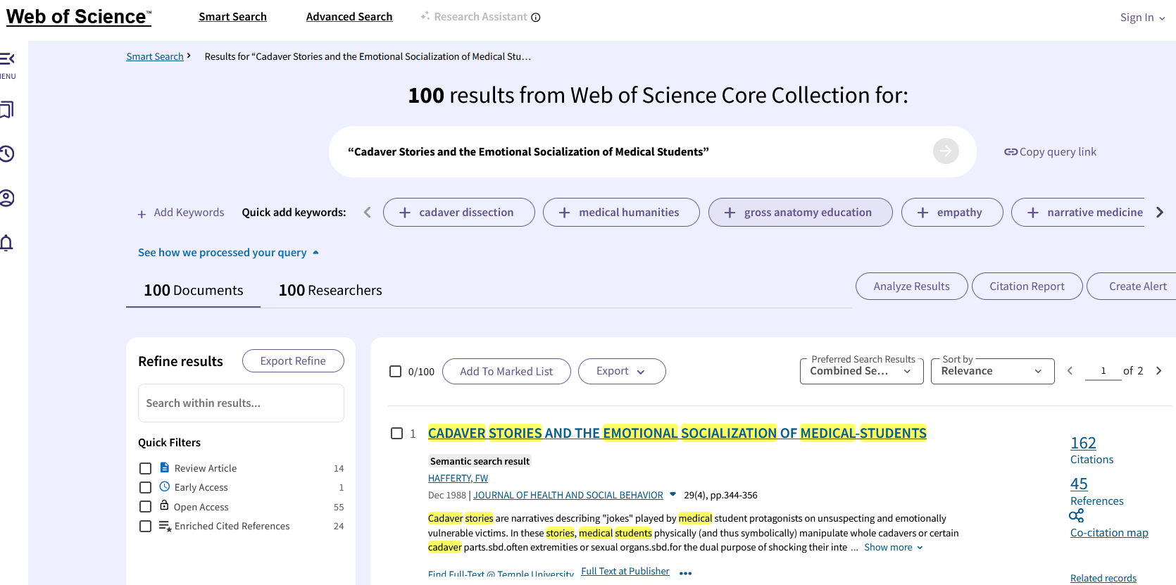

- Click on “Citations” on the left. This leads to articles that have cited your selected reading in later articles.
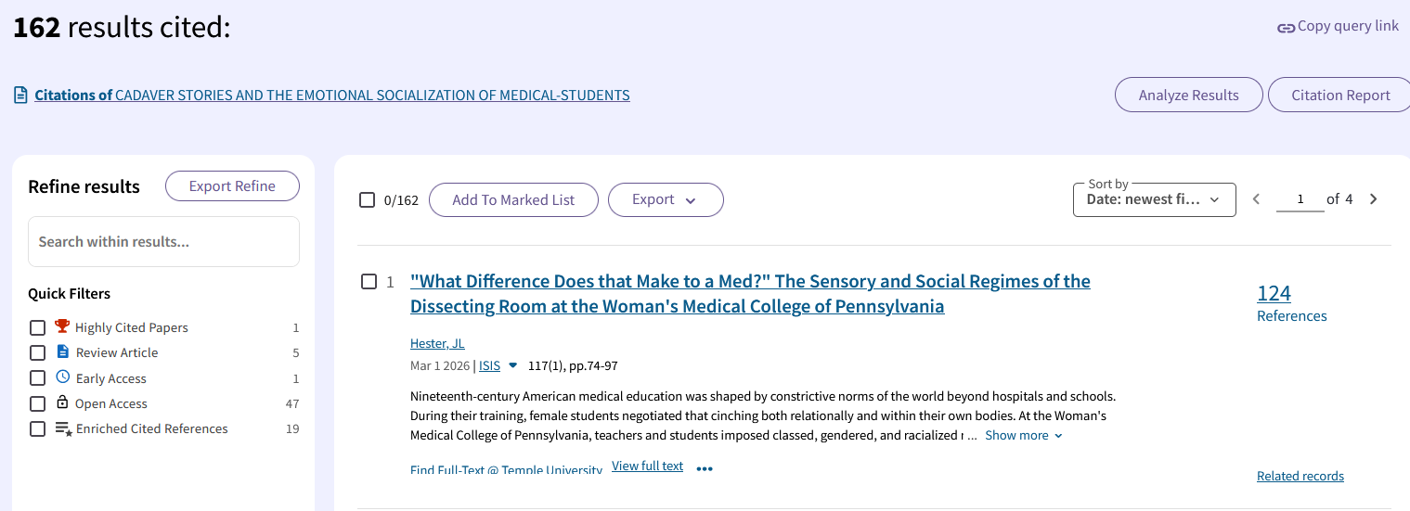
- Click on the title of one of the articles that interests you to see the full record.
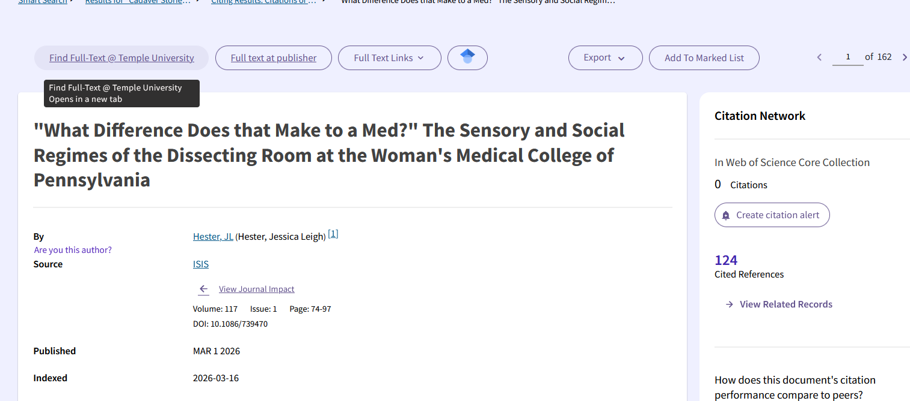

- Click on “Find full text @ Temple University.” This will search to see if Temple has direct access to the article.
- Save the citation information on your document.
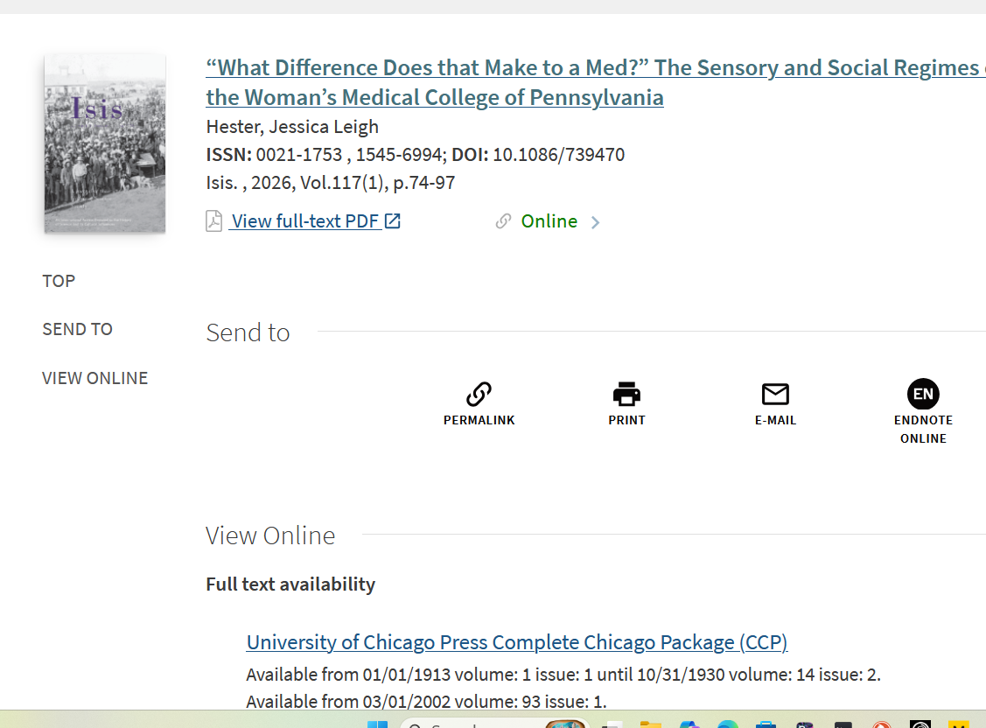

- Click on one of the links under “Full text availability”. (If there are no links, Temple does not have direct access. Try another citing article.) This should take you to the article itself in another database.
- Copy and paste or type the citation information about this article on your document.

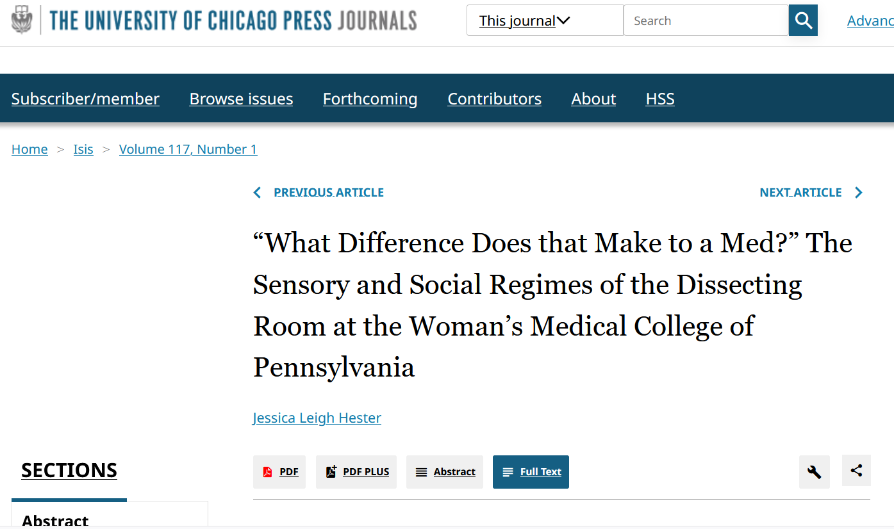

- Search the name of the author from the class reading to find the citation number.
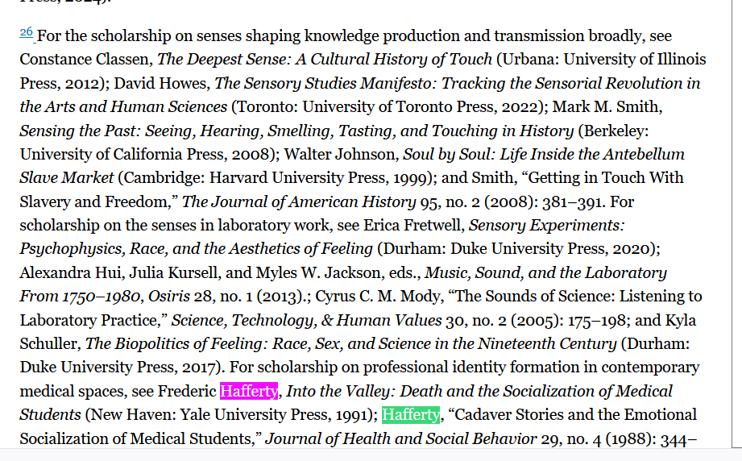
- Go to that citation in the article and copy and paste the sentence or sentences that indicate how the citation is being used by the new author.
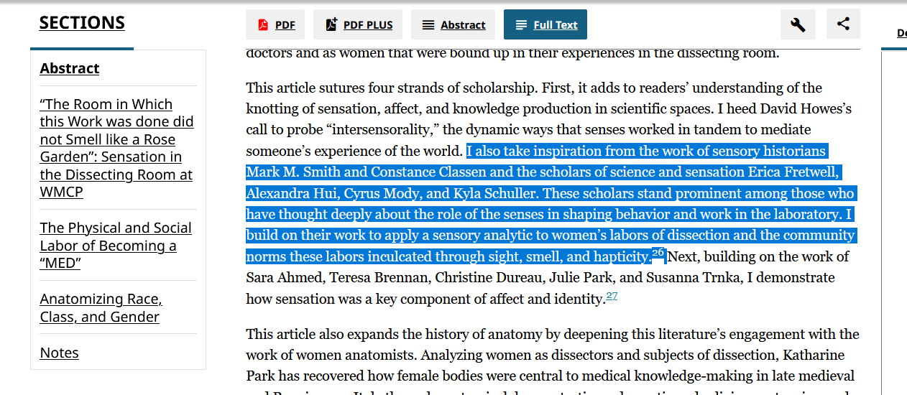

- Copy and paste the sentence(s) on your document. You should now have two citations, (1) the reading plus (2) the citing article, and the sentence(s) that explain how it is being used.
- Now that you’ve seen how one article has cited or applied the reading that interests you, write 1-2 sentences about how you could use this article. Please note that it doesn’t have to be related to your future letter; this is more oriented around practicing applying knowledge.
- Finally, please add 3-4 sentences on your proposed concept or finding—and how you think it addresses an ethical and humanistic problem in your future career.

All told, this in-class brainstorm day exercise should yield a document to upload to Canvas that has:
- Two citations (one from the course, one that cites that one you selected from the course)
- A verbatim quote from the second (citing) article that illustrates how the author(s) applied or used the first author’s ideas
- 1-2 sentences about how you would use this article
- 3-4 sentences about your proposed concept or finding and how you think it addresses an ethical and humanistic problem in your future career

GRADING SYSTEM

(letter grade / numerical grade / grade points)

A 92.5-100% 4.0
A- 90-92.49% 3.67
B+ 87.5-89.99% 3.33
B 82.5-87.49% 3.00
B- 80-82.49% 2.67
C+ 77.5-79.99% 2.33
C 72.5-77.49% 2.00
C- 70-72.49% 1.67
D+ 67.5-69.99% 1.33
D 62.5-67.49% 1.00
D- 60-62.49% 0.67
F 0-59.99% 0.00

COURSE LOGISTICS

All required readings are listed in the Syllabus. You can find them and download them on the Temple Libraries site by either looking up the author or looking up the journal. Some days I might bring physical copies of these articles to class so we can do deep reading together. The articles are either classics within sociology, health and healthcare focused, or seem like fun explications of concepts we will be reviewing in lecture.

Some readings are in this free textbook (you need to be logged into the Temple Libraries site with your credentials to access it): OpenStax Textbook. The textbook is meant to give an overview of concepts and ideas that I will expand upon or supplement in lecture.

IMPORTANT POLICIES

Respect
The discipline of sociology and the professions concerned with providing healthcare cover topics that are sensitive. As such, participation in this course requires that you respect your peers and the subjects discussed in the course. Please act with interest, humility, and empathy.

Disability Accommodation
Temple University is committed to the inclusion of students with disabilities and provides accessible instruction, including accessible technology and instructional materials. The process for requesting access and accommodations for this course is: (1) Advise me of the need for access or accommodations; (2) Contact Disability Resources and Services to request accommodations (215-204-1280); (3) DRS will consult with me as needed about essential components of the program; (4) Present me with a DRS accommodation letter. If you have any questions or concerns about the process above, please do not hesitate to ask me.

Course Costs
The required course materials for this course are open educational resources and are available at no cost to students.

Email
I love working with students, troubleshooting problems, and doing whatever I can to help you succeed. Please email me and allow me a 24-hour period to return your emails. I usually respond before then, but it is important to keep in mind, particularly if you have a time-sensitive question.

Technology
Because AI, cell phones, and laptops have been shown to limit active engagement and learning in college classrooms, this will be a tech-free classroom. That means that unless we are doing an explicit assignment that involves digital devices, keep your devices tucked away in your coats or bags. I will remind students and if it becomes a frequent problem, it will negatively impact your attendance/participation grade.

AI Use Prohibited
The use of generative AI tools (such as ChatGPT, Perplexity, DALL-E, etc.) are not permitted in this class; therefore, any use of AI tools for work in this class may be considered a violation of Temple University’s Academic Honesty policy and Student Conduct Code, since the work is not your own. Not only is there no need to use them for this course, because trying to read and understand texts as well as trying to write one’s own reflections is pivotal to the course’s objectives, but there are also an additional set of concerns about AI tools, in general, namely that:

- they contribute to more bias and inequality,
- they dehumanize the process of learning,
- they diminish the potential for critical thinking,
- they pose privacy and security threats to users,
- they incite hallucinations and persuade people to harm themselves,
- they were designed using stolen intellectual and artistic resources,
- they are displacing humans in jobs,
- and, the physical infrastructure needed to energize AI farms are contributing to the displacing of humans, rising environmental burdens on neighboring communities, and an acceleration of climate change

The use of unauthorized AI tools will result in zero points for the question or assignment it is used for and will be considered a violation of academic integrity.

Academic Integrity
If you have any questions about how to paraphrase, cite, or work with integrity, please do not hesitate to ask me. For the policy, please refer to the verbatim policy from the university below:

Temple University believes strongly in academic honesty and integrity. Essential to intellectual growth and the university's core educational mission is the development of independent thought and a respect for the thoughts of others. Academic honesty fosters this independence and respect. Academic dishonesty undermines the university's mission and purpose and devalues the work of all members of the Temple community. Every member of the university community is responsible for upholding the highest standards of honesty at all times. Students, as members of the community, are responsible for adhering to the principles of academic honesty and integrity.

Plagiarism includes, but is not limited to, the use, by paraphrase or direct quotation, of the published or unpublished work of another person without full and clear acknowledgment. It also includes the unacknowledged use of materials prepared by another person or agency engaged in the selling or distribution of term papers or other academic materials. Normally, all work done for courses — papers, examinations, homework exercises, laboratory reports, oral presentations — is expected to be the individual effort of the student presenting the work. Any assistance must be reported to the instructor. If the work has entailed consulting other resources — journals, books, or other media — these resources must be cited in a manner appropriate to the course. It is the instructor's responsibility to indicate the appropriate manner of citation. Everything used from other sources — suggestions for organization of ideas, ideas themselves, or actual language — must be cited. Failure to cite borrowed material constitutes plagiarism. Undocumented use of materials from the World Wide Web is plagiarism.

Cheating includes, but is not limited to: (1) use of any unauthorized assistance in taking quizzes, tests, or examinations; (2) use of sources beyond those authorized by the instructor in writing papers, preparing reports, solving problems, or carrying out other assignments; (3) the acquisition, without permission, of tests or other academic material belonging to a member of the university faculty or staff; (4) engaging in any behavior specifically prohibited by a faculty member in the course syllabus, assignment, or class discussion; (5) or otherwise engaging in behavior that gives the student an unfair academic advantage including, but not limited to, fabrication of data or sources, resubmitting work already submitted for another academic requirement without prior authorization, or other similar behavior.

Refer to the Student Conduct Code (policy # 03.70.12) for more specific definitions of cheating and plagiarism. The penalty for academic dishonesty can vary from receiving a reprimand and a failing grade for a particular assignment, to a failing grade in the course, to suspension or expulsion from the university. The penalty varies with the nature of the offense, the individual instructor, the department, the school or college, and the Office of Student Conduct and Community Standards. Students who believe that they have been unfairly accused may appeal through the school or college's academic grievance procedure. For more information see Grievances.

FURTHER RESOURCES

Cherry Food Pantry Room 224A, Second Level, Howard Gittis Student Center North

Student Health Services (215-204-7500) Tuttleman Counseling Services (215-204-7276)

Wellness Resource Center (215-204-8436) Campus Safety (215-204-1234)

Philadelphia Sexual Assault Response Center (215-425-1625)

Pennsylvania Immigration and Citizenship Coalition (215-832-0636)

IDEAL Space 2026 N. Broad Street

